MARE-WINT
Report MARE-WINT / Partner's short name / No
Report title

Acronym | MARE-WINT
Full Title | new MAterials and REliability in offshore WINd Turbines technology
Project reference: | 309395
Start Date | 2012-10-01
Document reference | Document reference
Issue & date | DD.MM.YYYY
Type of document | Review Report
Author/reporting | Author / Partner Short name
Status | Draft
Revised/approved by | MARE-WINT Project Coordination Committee | DD.MM.YYYY
Distribution | Copy to :  marewint-info@imp.gda.pl
Sensitivity | CONFIDENTIAL within MARE-WINT

Table of content
1. Introduction 3
1.1 Task overview and positioning in the Aquilo project structure 3
1.1.1 Concept 3
2. TEXT body in sections/subsections 4
2.1 subsection 4
2.1.1 Sub/subsection 4
3. Conclusion 4
4. Bibliography 4

List of Figures
Figure 1-1: Offshore wind turbine support structures 3

List of Tables
Table 1: Overview 3

Introduction

Task overview and positioning in the Aquilo project structure
This report

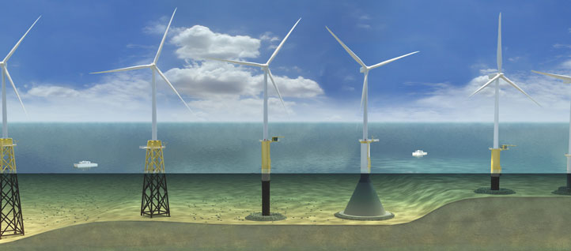

Figure 1-1: Offshore wind turbine support structures

Concept
This report
is summarised in Table 1.

Table | Autofit to content
Table 1: Overview

TEXT body in sections/subsections

subsection

Sub/subsection

Conclusion
This report is

Bibliography
- Other reports
- Conference proceedings
- Journal papers

